The Big Picture
An Easter Story
March 31, 2013

Lesson Objective:
To grasp the impact Christ’s resurrection has had on your life.
Scripture Focus: John 20:1‐20

Overview: The resurrection of Christ is the hinge‐point of history. It was the moment when the world was more‐or‐less put on notice. In an instant, Jesus went from being perceived by many as “the itinerant rabbi leading a motley band of misfits around the countryside performing miracles and preaching about God’s Kingdom,” to “the Son of God who was exactly who He said He was, and who did what He said He would do.” The resurrection put so much of Jesus’ teaching and ministry in perspective. (It certainly cast a clarifying light on His death.) But it did more than that: it infused the future with a hope that was unknown before Christ emerged from the tomb. Jesus had conquered sin and death. This hope has moved humankind since that moment.

Yesterday, our children were invited by their friends for brunch and an Easter Egg hunt. It was their friends’ fun family celebration and tradition over the years. We had a good time getting to know this family better. While it’s great to enjoy some of the secular expressions of the holiday, such as Easter Bunnies, and of course, candy, the deeper meaning of Easter is one that has a tremendous impact on every believer. For the next few minutes, we are going to take the time to immerse ourselves in the Easter narrative and to examine what the story means to each one of us.

The Big Idea
We are about to take a sweeping look at the last moments of Jesus’ life.
• Where we pick up the story, Jesus is at the very end of His earthly ministry.
• He has been teaching, healing, and performing other miracles all throughout the regions of Galilee, Samaria, and Judea for three years.
• For three years, Jesus’ 12 disciples have been His constant companions, learning from Jesus.
• There were other followers of Christ as well, particularly Mary Magdalene, whom we’ll see in today’s lesson.
• Jesus had made enemies of the religious establishment. His teachings from God’s Kingdom threatened to take away the power and influence they enjoyed.

We’re going to
- Read through some passages of Scripture that lead up to the resurrection of Christ.
- Look at some classic paintings depicting the last moments of Jesus’ life that correspond with the scenes in Scripture. (The point of the images is to simply help you get a mental picture of the events surrounding Christ’ resurrection.)

Passages:
• Matthew 26:36-39 ---Praying in the Garden (Artist: Gustav Dore)
³⁶ Then Jesus came with them to a place called Gethsemane, and said to the disciples, “Sit here while I go and pray over there.” ³⁷ And He took with Him Peter and the two sons of Zebedee, and He began to be sorrowful and deeply distressed. ³⁸ Then He said to them, “My soul is exceedingly sorrowful, even to death. Stay here and watch with Me.”
³⁹ He went a little farther and fell on His face, and prayed, saying, “O My Father, if it is possible, let this cup pass from Me; nevertheless, not as I will, but as You will.”
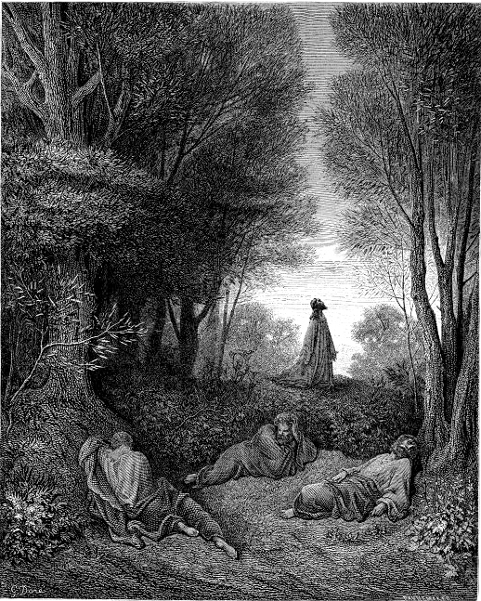

What does this passage reveal to you about Jesus and the sacrifice He would soon make on the cross? How did Jesus feel? Was this an easy assignment to face?

• Matthew 26:47-56 ---Arrest in the Garden (Artist: Hans Holbein)
⁴⁷ And while He was still speaking, behold, Judas, one of the twelve, with a great multitude with swords and clubs, came from the chief priests and elders of the people.
⁴⁸ Now His betrayer had given them a sign, saying, “Whomever I kiss, He is the One; seize Him.” ⁴⁹ Immediately he went up to Jesus and said, “Greetings, Rabbi!” and kissed Him.
⁵⁰ But Jesus said to him, “Friend, why have you come?”
Then they came and laid hands on Jesus and took Him. ⁵¹ And suddenly, one of those who were with Jesus stretched out his hand and drew his sword, struck the servant of the high priest, and cut off his ear.
⁵² But Jesus said to him, “Put your sword in its place, for all who take the sword will perish by the sword. ⁵³ Or do you think that I cannot now pray to My Father, and He will provide Me with more than twelve legions of angels? ⁵⁴ How then could the Scriptures be fulfilled, that it must happen thus?”
⁵⁵ In that hour Jesus said to the multitudes, “Have you come out, as against a robber, with swords and clubs to take Me? I sat daily with you, teaching in the temple, and you did not seize Me. ⁵⁶ But all this was done that the Scriptures of the prophets might be fulfilled.”
Then all the disciples forsook Him and fled.
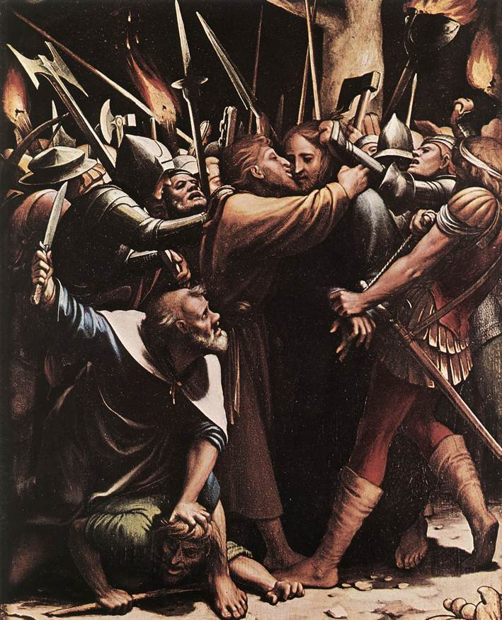

This account of Jesus’ arrest reveals a lot about Jesus’ character and mission. What do you notice in these verses that speak to Jesus’ character? What here speaks to His mission?
• Matthew 26:57-66 --- Trial before the Sanhedrin (Artist: Mihaly Munkacsy)

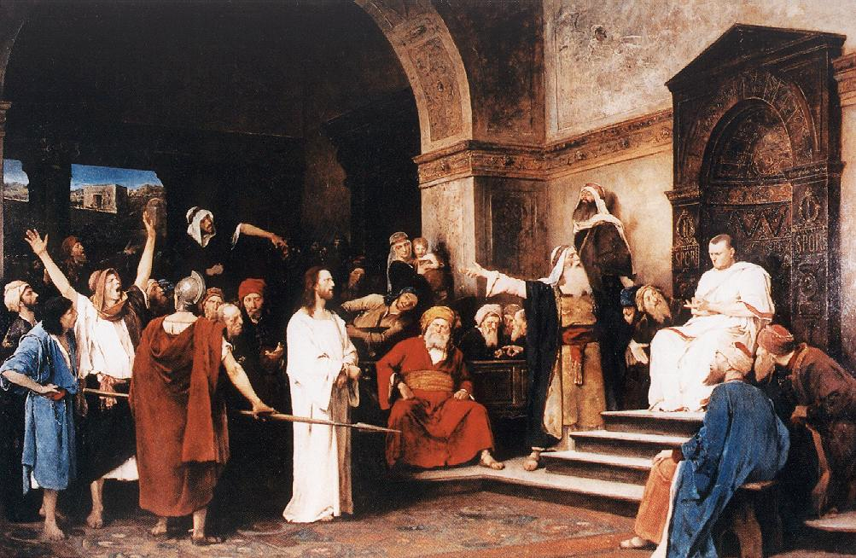

Jesus was basically put to death for telling the truth about His identity. Why do you think people today still choose not to see Jesus for who He is? What obstacles in people’s lives keep them from coming to Christ?

• Matthew 27:27-31 and 45-54 --- Crucifixion & Death (Artist: Rembrant)
²⁷ Then the soldiers of the governor took Jesus into the Praetorium and gathered the whole garrison around Him. ²⁸ And they stripped Him and put a scarlet robe on Him. ²⁹ When they had twisted a crown of thorns, they put it on His head, and a reed in His right hand. And they bowed the knee before Him and mocked Him, saying, “Hail, King of the Jews!” ³⁰ Then they spat on Him, and took the reed and struck Him on the head. ³¹ And when they had mocked Him, they took the robe off Him, put His own clothes on Him, and led Him away to be crucified.
⁴⁵ Now from the sixth hour until the ninth hour there was darkness over all the land. ⁴⁶ And about the ninth hour Jesus cried out with a loud voice, saying, “Eli, Eli, lama sabachthani?” that is, “My God, My God, why have You forsaken Me?”
⁴⁷ Some of those who stood there, when they heard that, said, “This Man is calling for Elijah!” ⁴⁸ Immediately one of them ran and took a sponge, filled it with sour wine and put it on a reed, and offered it to Him to drink.
⁴⁹ The rest said, “Let Him alone; let us see if Elijah will come to save Him.”
⁵⁰ And Jesus cried out again with a loud voice, and yielded up His spirit.
⁵¹ Then, behold, the veil of the temple was torn in two from top to bottom; and the earth quaked, and the rocks were split, ⁵² and the graves were opened; and many bodies of the saints who had fallen asleep were raised; ⁵³ and coming out of the graves after His resurrection, they went into the holy city and appeared to many.
⁵⁴ So when the centurion and those with him, who were guarding Jesus, saw the earthquake and the things that had happened, they feared greatly, saying, “Truly this was the Son of God!”
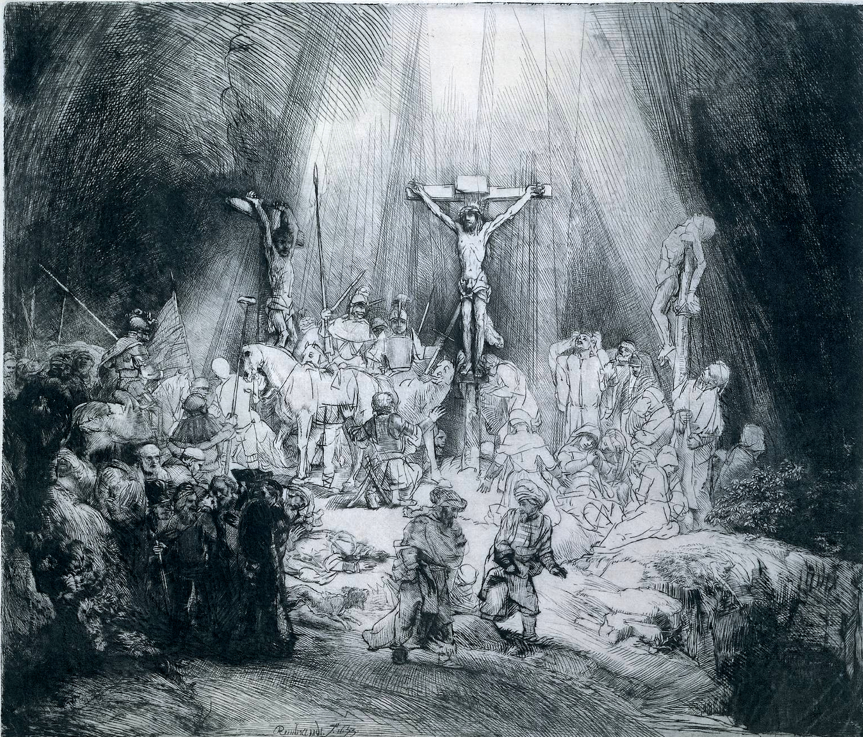

In your own words, what emotions or thoughts come to mind when you consider that Christ willingly submitted Himself to God’s wrath by taking on our sins on the cross?
• Matthew 27:57-65 ---Burial (Artist: Sisto Badallochio)
⁵⁷ Now when evening had come, there came a rich man from Arimathea, named Joseph, who himself had also become a disciple of Jesus. ⁵⁸ This man went to Pilate and asked for the body of Jesus. Then Pilate commanded the body to be given to him. ⁵⁹ When Joseph had taken the body, he wrapped it in a clean linen cloth, ⁶⁰ and laid it in his new tomb which he had hewn out of the rock; and he rolled a large stone against the door of the tomb, and departed. ⁶¹ And Mary Magdalene was there, and the other Mary, sitting opposite the tomb.
⁶² On the next day, which followed the Day of Preparation, the chief priests and Pharisees gathered together to Pilate, ⁶³ saying, “Sir, we remember, while He was still alive, how that deceiver said, ‘After three days I will rise.’ ⁶⁴ Therefore command that the tomb be made secure until the third day, lest His disciples come by night and steal Him away, and say to the people, ‘He has risen from the dead.’ So the last deception will be worse than the first.”
⁶⁵ Pilate said to them, “You have a guard; go your way, make it as secure as you know how.”
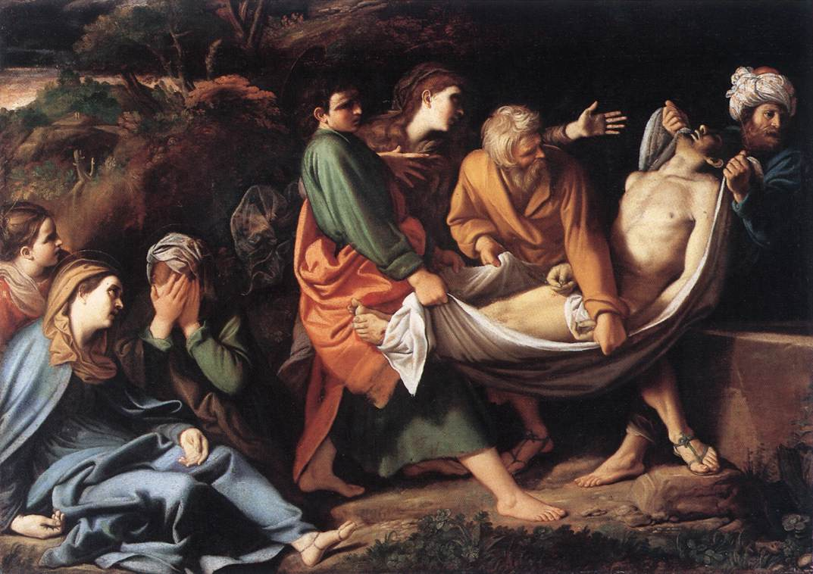

Is it interesting to you that even the enemies of Jesus knew the kind of things He was teaching? What does this say about Jesus’ enemies? What does this say about Jesus’ influence?
Think about where you are in the story:
• What would you be feeling is you were one of Jesus’ disciples? After all, they had spent three years with Jesus. Knowing He was dead in the tomb, what do you think might have been going through their minds?
• What are some words that would describe how you might feel if you were one of the “two Mary’s,” sitting-by watching Jesus be buried?
• What are some words that describe the situation as a whole at this point in the story?

Of course, the story was not over. Read John 20:1-10
Now on the first day of the week Mary Magdalene went to the tomb early, while it was still dark, and saw that the stone had been taken away from the tomb. ² Then she ran and came to Simon Peter, and to the other disciple, whom Jesus loved, and said to them, “They have taken away the Lord out of the tomb, and we do not know where they have laid Him.”
³ Peter therefore went out, and the other disciple, and were going to the tomb. ⁴ So they both ran together, and the other disciple outran Peter and came to the tomb first. ⁵ And he, stooping down and looking in, saw the linen cloths lying there; yet he did not go in. ⁶ Then Simon Peter came, following him, and went into the tomb; and he saw the linen cloths lying there, ⁷ and the handkerchief that had been around His head, not lying with the linen cloths, but folded together in a place by itself. ⁸ Then the other disciple, who came to the tomb first, went in also; and he saw and believed. ⁹ For as yet they did not know the Scripture, that He must rise again from the dead. ¹⁰ Then the disciples went away again to their own homes.

• How could the disciples have spent all those years with Jesus and not have understood that He had risen from the dead just as He said He would?
Possible answers: They were highly emotional; they were under a ton of stress with all that happened; their judgment was clouded by grief; they had not yet been given the indwelling of the Spirit and did not have the Spirit to teach and remind them of the spiritual connections between what Jesus taught and what had occurred.
• If you could put yourself in their shoes, what do you think the walk home must have been like?

Read John 20: 11-20
¹¹ But Mary stood outside by the tomb weeping, and as she wept she stooped down and looked into the tomb. ¹² And she saw two angels in white sitting, one at the head and the other at the feet, where the body of Jesus had lain. ¹³ Then they said to her, “Woman, why are you weeping?”
She said to them, “Because they have taken away my Lord, and I do not know where they have laid Him.”
¹⁴ Now when she had said this, she turned around and saw Jesus standing there, and did not know that it was Jesus. ¹⁵ Jesus said to her, “Woman, why are you weeping? Whom are you seeking?”
She, supposing Him to be the gardener, said to Him, “Sir, if You have carried Him away, tell me where You have laid Him, and I will take Him away.”
¹⁶ Jesus said to her, “Mary!”
She turned and said to Him,“Rabboni!” (which is to say, Teacher).
¹⁷ Jesus said to her, “Do not cling to Me, for I have not yet ascended to My Father; but go to My brethren and say to them, ‘I am ascending to My Father and your Father, and to My God and your God.’”
¹⁸ Mary Magdalene came and told the disciples that she had seen the Lord, and that He had spoken these things to her.
¹⁹ Then, the same day at evening, being the first day of the week, when the doors were shut where the disciples were assembled, for fear of the Jews, Jesus came and stood in the midst, and said to them, “Peace be with you.” ²⁰ When He had said this, He showed them His hands and His side. Then the disciples were glad when they saw the Lord.
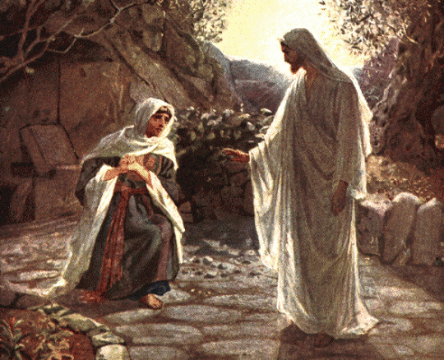

• Describe Mary’s attitude toward Christ.
• How would you describe her relationship with Christ? What evidence do you have for your answer?
• Mary might not have recognized Jesus because it was still kind of dark, or because she was still looking in the tomb, or because her eyes were full of tears. Regardless, when He said her name, she immediately recognized Jesus. What can we learn from Jesus’ relationship to us, His children, from this passage?
Answer: He knows us intimately and personally. And just as importantly, we can know Him personally, as well.

The narrative of Jesus’ death, burial, and resurrection is complete. The Scripture tells us that Jesus would appear to the disciples numerous times over a 40-day period before ascending to heaven to dwell with God the Father. You can be certain that Christ’s resurrection from the dead is the absolute proof that Jesus was who He said He was: the Son of God who came to take away the sins of the world. Had Jesus stayed in the tomb, He would have been perceived as nothing more than a great teacher and a godly man. But through His resurrection, Jesus confirmed His true identity, won a victory over sin and death, and paved the way for all believers to be free from the penalty of sin, and to live with Him for eternity.

Wrap Up
Responding to the story.

The Easter story is remarkable in itself. But what is more remarkable is what it means for us and for the world.

What do you think the main takeaways of the story are? In other words, what are you supposed to “do” with what you’ve just read?

(Answers given today: Re-evaluate where I am with Jesus. Recognizing His voice like Mary. How much He suffered on the cross. Gratitude.)

• Jesus is who He said He was. He predicted that He would die, but rise again, a miraculous act that proved Jesus’ deity. Jesus’ resurrection confirmed His identity. We can believe in Jesus.
• Jesus’ resurrection bought us life. The Bible says sin earns us death (Rom. 6:23). On the cross, Jesus took the penalty of our sins on Himself. His death paid the debt our sins earned. But His resurrection overcame the power of death. If we accept Jesus’ sacrifice on our behalf, Scripture says our debt is canceled, and we gain eternal life.
• This news can’t be contained. Mary immediately went and told the disciples. And in John 20:21, right after Jesus appeared to the disciples, He said to them, “As the Father has sent Me, I am sending you.” The life-giving message of Jesus’ identity and resurrection are a gift we are called to share with others. We can’t keep it to ourselves.

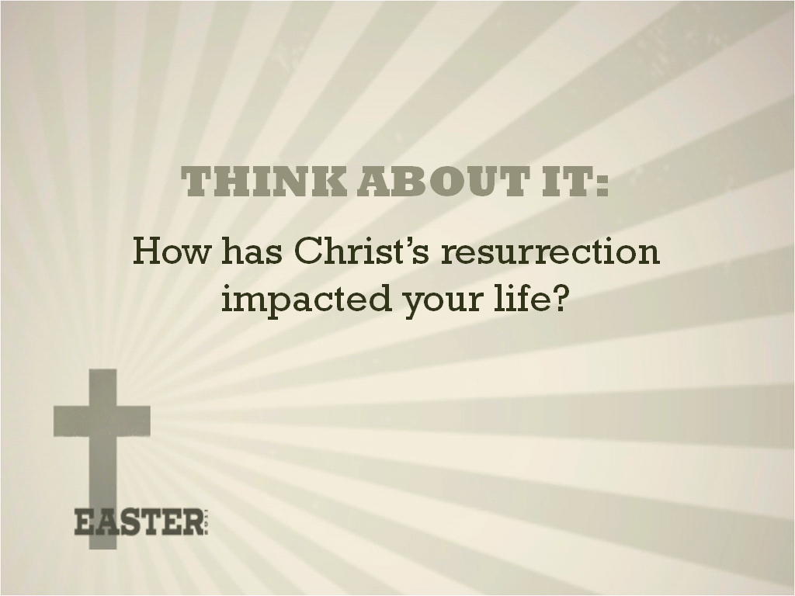

Take a few moments and think about your personal response to the implications of Jesus’ resurrection. Consider what Christ’s resurrection means to you, or what aspects of it makes the biggest impact on your life, or how it makes you feel. Consider how your life is radically different because Jesus is not still in the tomb. Write down your response.

Conclusion: Christ’s resurrection is the hinge-point of our faith. We live because Christ lived! Allow your life to be impacted by the sacrifice Christ made on your behalf, and the incredible story of His resurrection.

©2011youthministry360

